**MAGNETIC COOLANT SEPARATOR**

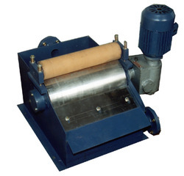

|  |
| --- |
| The Coolant Fluid with iron Dust particles Falling by Gravity to the Inlet of the Separator from the Precision Machine Tools such as Grinders, Milling Machines, Automates etc. The Coolant with Iron impurities come in to contact with Magnetic Drum and extracts all Iron particles.  **Magnetic Coolant Separator With filtration system** **Capacity    (See Fig. No- 16)** 50    LTRS/ MIN         60-70LTRS/MIN       100Ltrs/Min                 120LTRS/MIN             150Ltrs/Min                 200 Ltrs/Min |

**Features**

Ø     Ideal for milling, grinding and general machining

Ø     **Inlet base in SS**

Ø     Remove particles from 5 micron upwards

Ø     Complete with motor & double reduction gear box.

Ø     Operates with soluble or near cutting oils

Ø     Efficient pre-filter for high levels of ferrous content

Ø     Continuous automatic operation-maintenance free

Ø     Rugged design for long-life

Ø     Magnetic drum in High Power

**SUSPENSION MAGNET ( TO USE ON CONVEYOR BELT )**  
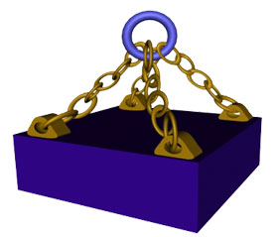

|  |
| --- |
| **Sizes** |
| **600 x 300 x 100MM** |
| **600 x 400 x 100MM** |
| **600 x 500 x 150MM** |
| **800 x 500 x 150MM** |
| **1000 x 600 x 150MM** |
| **1500 x 800 x 150MM** |

Suspension Type Magnets are most useful for products carried by the Belt Conveyors.  
  
Use of Suspension Type Magnets is recommended for products with low contamination. However if the frequency of the impurities is too high, these will make a layer shunting magnetic field. The equipment will require frequent cleaning. For such applications Over Band type Magnetic Separator is recommended.  
  
The main applications are for the processing of Bulk products such as Sugar, Coal, Minerals, Cereals, Coffee, Glass, Culets etc.

|  |  |  |
| --- | --- | --- |
| suspensiondrawing   |  |  | | --- | --- | | suspension-1 | suspension-2 | |

**Installation :**JMPL magnets can be installed either at the end of the belt above the head drum  (Fig 1), or across the conveyor belt ( Fig. 2 ).

In both cases, to avoid disturbances to the magnetic field, a magnetic parts must be planced below the surface of the magnet.

The installation shown on figure 1 is preferable for high speeds. Separation is more efficient due to the trajectory of the fact that it is then "fluidised".

**HOPPER MAGNET**

 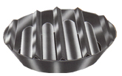

|  |  |
| --- | --- |
| |  | | --- | | This is a unique device to protect Plastic Extrudes/Moduling Machines against iron contamination such as Nuts, Nails, Iron Bits etc. and ensure the trouble free and smooth operation of the machine. Four standard sizes both in Round and square are available and can be selected on the basis of the size and shape of Hoppers. High power Magnetic Rods are provided which prevents any iron material to enter in to the Machine. Special size Hopper Magnets are also supplied. Most useful for Plastic, rice Mill, Flour Mills, Cattle feed & Guar Gum industries. Available in S.S. 304/316 construction also for Dyes & Chemical Industries. | |

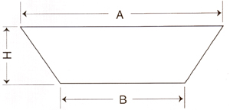

**Salient Features :**

|  |  |
| --- | --- |
| **abu098%5B1%5D** | PLATE MAGNET CONSISTS OF HIGH COROCIVITY MODERN ANISOTROPIC PERMANENT MAGNET LIKE |
| **abu098%5B1%5D** | FERRITE / RARE EARTH MAGNET. |
| **abu098%5B1%5D** | STRONG & RUGGED CONSTRUCTION WITH M . S OR S . S. 304/316 CONSTRUCTION. |

|  |  |  |  |  |  |
| --- | --- | --- | --- | --- | --- |
| **Type** | **CAT No. (Model No. As Per Catalogue Of JMPL)** | **DIM. A.**  **Mm** | **DIM.B.**  **Mm** | **DIM.H.**  **Mm** | **No. Of Magnetic Rods  &DIA** |
| **SQUARE** | J-571-S | 200 | 115 | 65 | 2 X 40mm |
| J-572-S | 250 | 165 | 65 | 2 X 40mm |
| J-573-S | 300 | 215 | 65 | 3 X 40mm |
| J-574-S | 375 | 290 | 65 | 4 X 40mm |
| **ROUND** | J-575-R | 200 | 115 | 75 | 2 X 40mm |
| J-576-R | 250 | 165 | 75 | 2 X 40mm |
| J-577-R | 300 | 215 | 75 | 3 X 40mm |
| J-578-R | 375 | 290 | 75 | 4 X 40mm |
|  | | | | | |
|  | | | | | |